B.Tech II Year, Computer Organization Lab

*Practical 01*

**Prepare the c program for the followings with separate header file consists of all functions that you are using in the programs:**

1. Take a decimal number from command line and convert into binary number.

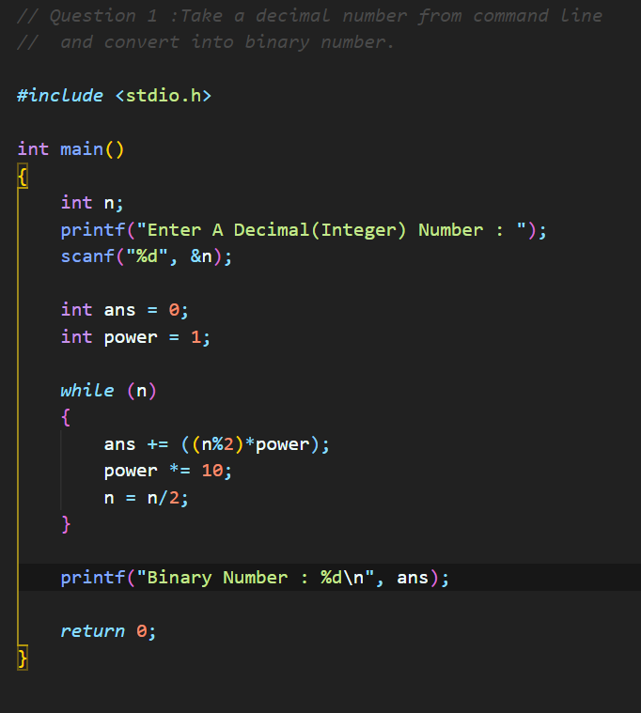

Some Test Cases: (10, 16, 100)

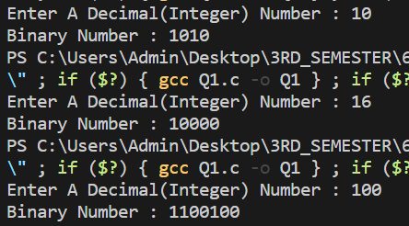

2. Take a binary number from command line and convert into decimal number.

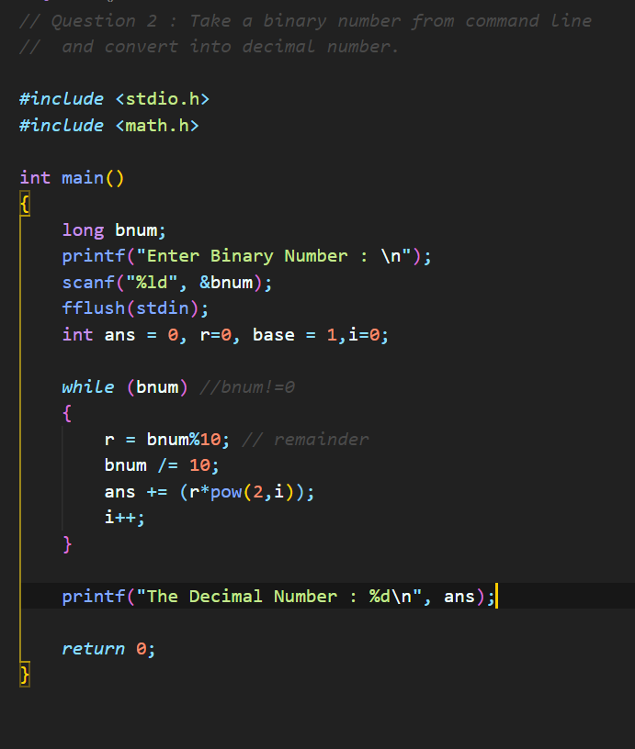

Some Test Cases: (1111, 1010, 11101)

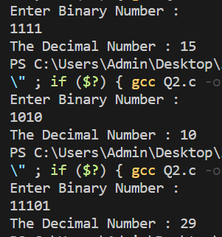

3. Take a decimal number from command line and display its factorial using recursion.

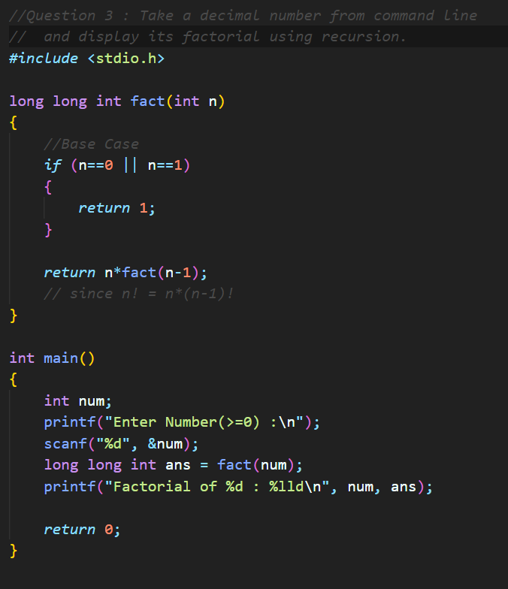

Some Test Cases: (3, 5, 7)

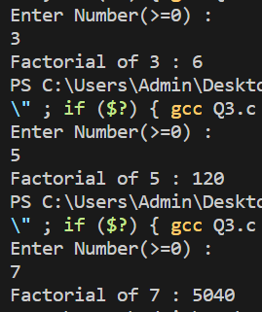

Submitted By:

Roll Number: U19CS012 (D-12)

Name: Bhagya Rana